**GSM BASED HOME AUTOMATION USING ARDUINO**

**Daniel Patrick E. Punzalan**

College of Engineering and Architecture

Angeles University Foundation

**Jesus Luigi M. Sison**

College of Engineering and Architecture

Angeles University Foundation

**Dr. Ruel V. Reyes**

Department of Computer Engineering

Faculty, College of Engineering and Architecture

Angeles University Foundation

**ABSTRACT**

Electrical appliances such as lighting systems, televisions, and refrigerators can be easily controlled and retrieved through home automation technology. The primary motivations for this technology are to make people's lives convenient, more techno driven, and effectively managed. These days, there are a number of applications that have been created with the help of a variety of technologies to make lives simpler.

This offers a significant solution to the problem of those who usually forget or leave their own appliance switching. Once neglected, it may result to unwanted leakages because of the prolonged connection to the power supply. With this concern, an effective method of controlling home appliances within one's immediate vicinity is proposed. In hopes of tackling these issues, the researchers developed a GSM-based home automation system.

The main aim of this project is to create a system that could remotely switch on and off home appliances via SMS and a built-in mobile application. System development entails designing the multiple hardware modules such as power supply, GSM, microcontroller, relays, loads, sensors, as well as designing the corresponding firmware for the system by utilizing the Arduino platform, along with the Arduino IDE and App Inventor.

The results of the system evaluation showed that it is effective in the remote control of home appliances, with the exception of the switching delay of the appliance varies based on how strong the GSM signal, which is reported before the switching takes place. On the other hand, the scheduling timer properly performs the time input and can be edited on the time scheduling input to toggle loads.

**Keywords**: *Home Automation, Arduino, GSM (Global System for Mobile Communication), SMS (Short Messaging Service), App Inventor, Appliances*

**INTRODUCTION**

Home automation has been extensively developed and made researches for years. It is the concept of controlling all home electronic appliances within one automatic system. Also, it is one of the standout technologies with the most noticeable improvements in innovation. Now, every household has access for home automation and it has become a convenient way of simplifying controls to home appliances. Within the context of industrialization, automation is an advancement by ensuring human operators with machinery to help them meet the physical demands of their jobs. Most people have mobile phones as a necessity thus, the world indeed has transformed into a digital village. At any given moment, an individual can be contacted with a mobile phone. But given the advancements, the mobile phone applications cannot just be restricted to sending SMS or starting conversations.

The idea of home automation began in the 1900s with the introduction of electric power distribution that eventually led to the creation of labor-saving appliances such as water heaters, washing machines, refrigerator, etc. By 1975, the home automation technology was based on controlling signals through electric power transmission courtesy of the development of X10 products which included console, lamp and appliance modules that led to commercialization. Then, Arduino was introduced in 2005 to help students and professionals create working projects that can relate within the digital environment and lead to many contributions and remain a great tool for creating projects today.

There are already existing products and components that aid automation of home appliances. Through this project, the researchers tried to show how to control appliances in a house with added features that promote energy efficiency to reduce overload of appliances. The project GSM-Based Home Automation using Arduino is a switch box device that can control appliances switching by sending an SMS through the GSM module with Arduino board.

**OBJECTIVES**

The aim of this project is to develop a home automation system-based on the GSM technology to switch home appliances automatically. Specifically, the project pursues to answer the following:

1. How to design a system that will automatically switch an appliance on and off?

2. How to design a switch box that can be controlled remotely using a mobile phone?

3. How to integrate an existing web application to a home appliance control?

4. How to design the other features of the home automation system?

**CONCEPTUAL FRAMEWORK**

The proposed conceptual framework is said to be a GSM-based Home Automation system using Arduino. The GSM innovation gives wide reach so the researchers can work for their specific framework. This innovation gives financially perceptive answers for controlling the home appliances distantly. Figure 1 above shows the block diagram of the system where each of the required hardware components and home devices is identified. The flow of the proposed home automation system is presented here as well.

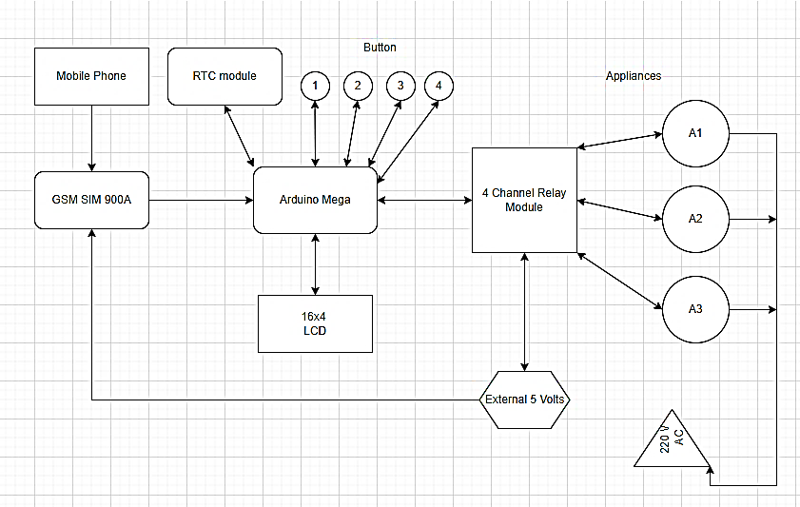

**Figure 1**: Conceptual Framework

The user will send an SMS from the mobile device, which will be received by a GSM module. Subsequently, the message will be transmitted to the Arduino Mega microcontroller connection. The four-relay channel module or the relay will function as a means of regulating the voltage for switching appliances on and off based on incoming messages received by the GSM module. An LCD module will serve as an interface for displaying the status of the appliances, and an RTC will be used to set the predetermined time for automatically activating and deactivating the appliances in the household. The buttons establish the time scheduling feature for a particular appliance, while the switchbox is capable of manually switching the appliances on and off.

**METHODOLOGY**

Hardware Resources

1. Arduino Mega 2560

The system used the Arduino Mega 2560 board (refer to Figure 2) which encompasses an ATmega2560 microcontroller that features 54 digital I/O pins, 15 PWM outputs, 16 analog inputs, 4 UARTs, 16 MHz crystal oscillator, USB port, power jack, and reset button. It includes all components required to support the microcontroller. With the use of a USB cable, one can connect it to a computer or power it with an AC-to-DC adapter or battery to run.

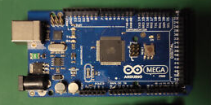

**Figure 2**: Arduino Mega 2560

2. SIM900A

SIM900A Modem, which was used as the component for the GSM-based communication for the proposed home automation system. It was built with Dual Band GSM and worked on frequencies 900/ 1800 MHz allowing functionality to transmit voice, SMS, data, and fax information at fast speeds while consuming little power. The SIM900A can search these two bands automatically. The frequency bands and baud rate can be set and configured respectively through the AT commands and they are used to control the modems. These sets of commands have four classifications: Test, Read, Set, and Execution.

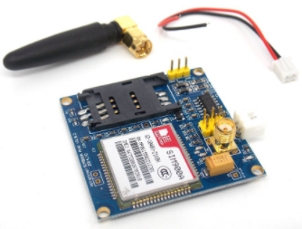

**Figure 3**: SIM900A GSM Module

3. Relay

The relay is a switch that is operated electrically by an electromagnet. It is used to control high voltage electronic devices such as motors, as well as low voltage electronic devices. It was used in the system to control high voltage devices such as home appliances by simply connecting it using the Arduino Mega board. The model used was the HL-54S, which is a four-channel relay module.

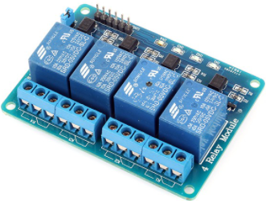

**Figure 4**: HL-54S 4-Relay Module

4. RTC Module

The RTC module, as shown in Figure 8, is an integrated circuit that stores the current time and date. The device incorporates a battery input and maintains accurate timekeeping when main power to the device is interrupted. It records seconds, minutes, hours, day, date, month, and year information. The date at the end of the month is automatically adjusted, specifically with those months that have days lesser than 31, including corrections for leap year.

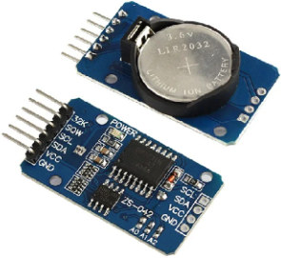

**Figure 5**: RTC Module

5. LCD Module

An LCD screen is an electronic display module. This component presents the status message of the proposed system. The model used for this hardware was the 16x04 I2C. It can display 16 characters per line with 4 available lines. It is capable of displaying 224 different characters and symbols along with I2C communication.

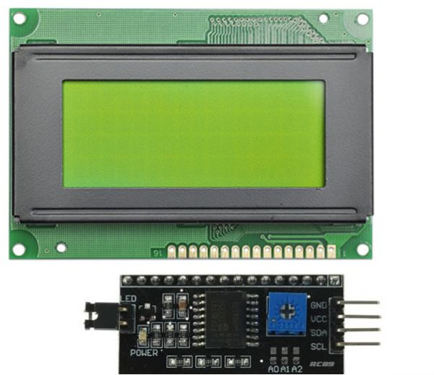

**Figure 6:** LCD I2C 16X02 Module

6. Buzzer

The buzzer module is used to make alarm sound when initialization executes, and for button control of the timer. For this project, the researchers used the piezo buzzer.

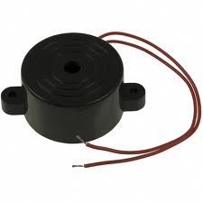

**Figure 7**: Piezo Buzzer Module

7. Push Button Switch

It is utilized in control by pressing functions such as dashboards and interfaces in automation systems. The connection to its contact terminals is established by means of screw terminals.

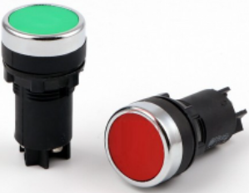

**Figure 8**: Push Button Switch

8. Keypad

4x4 keypad module that will be utilized when the user first started the system to input characters for the password. It consists of 4 row and 4 column keys, a total of 16 pressable keys.

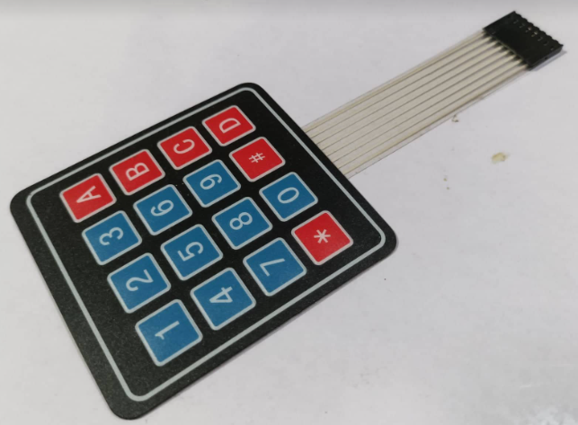

**Figure 9**: 4x4 Keypad

9. Switchbox

The switch box is the casing for the manual control for any electrical appliances. It can be used to turn ON/OFF appliances through pressing the manual switch.

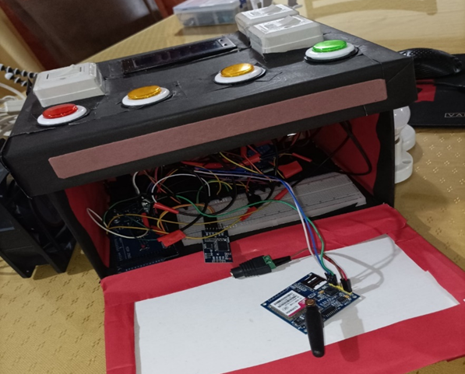

**Figure 10**: Actual Switchbox

Firmware Resources

1. Arduino IDE

The Arduino IDE (Integrated Development Environment) is a cross-platform application that is written in functions from C and C++. With the IDE, the user can write computer code or the sketch for the system and can-do additional programming or make changes depending on the purpose. It allows ease of programming the firmware at higher-level programming and conversion to hex for loading to the microcontroller.

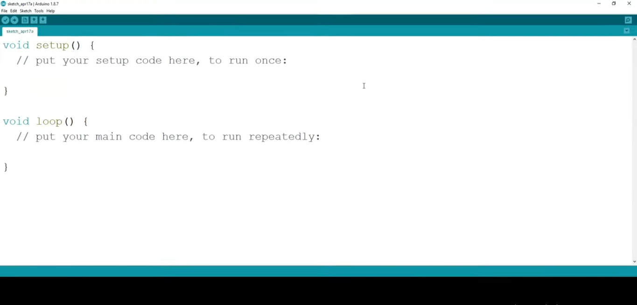

**Figure 11**: Arduino IDE Interface

2. App Inventor

App Inventor is an online web application IDE platform designed to teach various computational concepts through building Android mobile applications without any knowledge of programming.

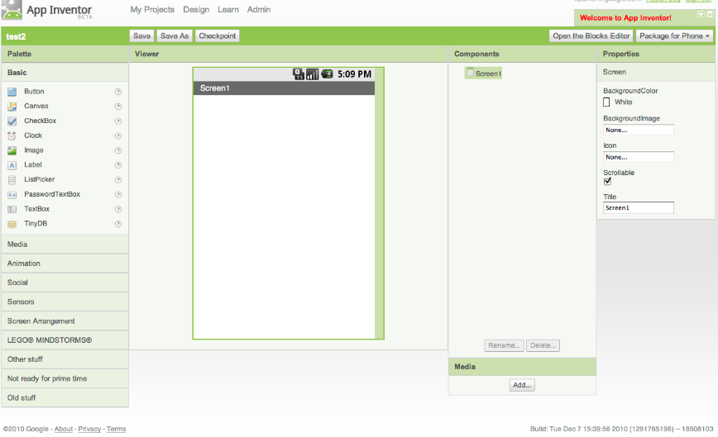

**Figure 12**: App Inventor Interface

**DEVELOPING THE PROJECT**

The model that was utilized for the project is an assortment of two models: V-model and ISO 26262. The V-model, also known as Validation and Verification model, is a framework illustrating the sequential stages of testing and developing software. The ISO 26262 standard is a guideline for electrical and electronic system protection. The purpose of project testing is to guarantee the required function and the project meets quality.

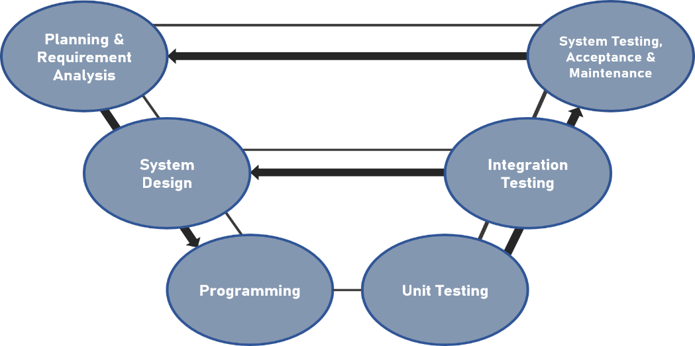

**Figure 13**: Model for the Project Testing

The researchers explored these methods in developing the project:

* Planning. Discussing arrangements for how the suggested system would really function.
* Requirement Analysis. An examination of the necessary components that are required for the project.
* System Design. This includes configuration of the projects’ hardware, firmware and communication.
* Programming. This includes the writing of the code for Arduino and the phone application. The Arduino offers tools to facilitate system implementation. It has a serial connection with an Arduino microcontroller. Printing to the serial terminal in the IDE enables the tracking of hardware and firmware function events.
* Unit Testing. It involves testing libraries of each required hardware module of the system.
* Integration Testing. This test validates libraries of various modules and are able to communicate with one another.
* System Testing. This is the real-time operation of the actual project. This checks how the whole application works and how it works with other parts. This checks if the project meets both functional and non-functional requirements.
* Acceptance Testing. This is testing and evaluating the system in the user environment.
* Project Maintenance. This is maintaining the quality of the components such as monitoring the component status of the SIM card storage capacity.

**PROGRAM FLOWCHART**

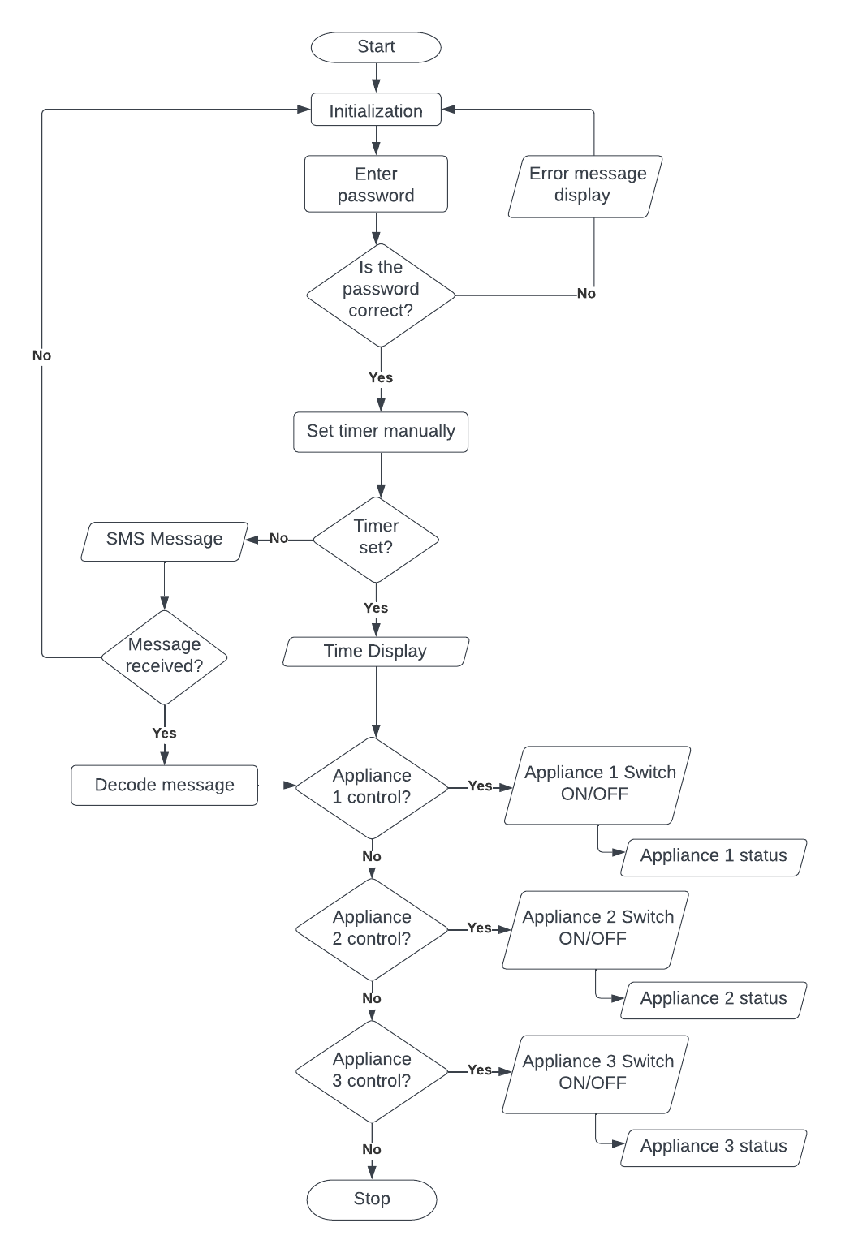

**Figure 14**: Program Flowchart

Figure 14 shows the program flowchart for the project, the workflow started with the initialization. It included password entry and setting the required baud rate for communication and preparation of the device to use. The timer was automatically set on the time the home automation system operated with the help of the RTC module. The exact time was displayed on the LCD where one could see the countdown of the user input. If the user prefers the other method, the identified input of the system should be the SMS message initiated from the mobile device and the home appliances as output. The decoded message would be used as the gateway to controlling the given home appliance. After the automatic switching, a text back message should be received by the user as the notification of the status of the appliance.

**SCHEMATIC DIAGRAM**

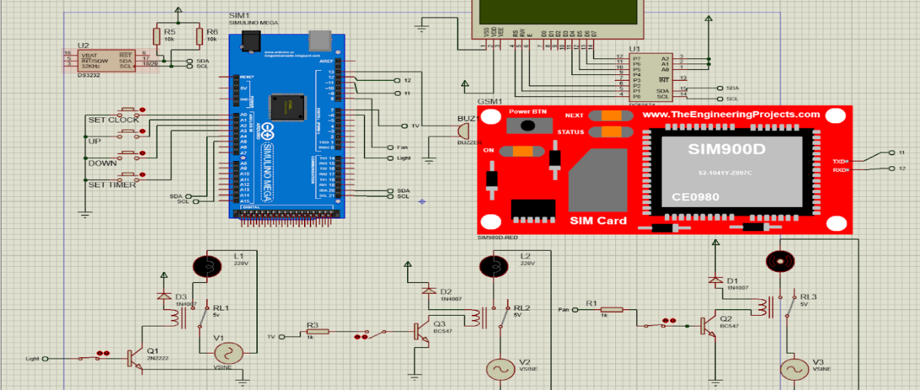

**Figure 15**: Schematic Diagram

The schematic representation of modules, sensors, corresponding pinouts and microcontrollers, as shown in Figure 14 enabled the researchers to freely create the project. In this project, the Arduino Mega board was used in controlling the whole process. The SIM900A was used for wireless communication in controlling the home appliances. The button was set to a timer to manually turn on/off the appliances in a specific time. The Arduino received the message through GSM, then sent the signal to the relay driver. The loads had a corresponding resistance with the help of relay for voltage management and LCD module for the display running in I2C communication. The researchers defined the commands to control the appliance for which the Arduino decoded the message from the GSM module.

**RECOMMENDATION**

Listed below are the areas that the researchers recommended to be reconsidered in case the next generation pursues the same study and plans to make improvements:

* Extended controls such as speed of the fan and the brightness of lights.
* Building a utility mobile application for home automation.
* Advanced security measures such as encryption.
* The design of the switchbox can be further improved with additional materials that support the strength and compactness of the system.

**CONCLUSION**

This research study titled “GSM-Based Home Automation Using Arduino” is deemed to be successful. This system includes an Arduino Mega board, GSM Module, a mobile device, electrical and other electronic components, and home appliances. It is user-friendly, accessible, and economical. Furthermore, it can be determined that this project's requirements are fulfilled, and the following are its indications: Built a home automation system that switches on and off appliances automatically; designed a switch box that can be controlled remotely using a mobile device; integrated an existing mobile application for home appliance monitoring; and designed other features suitable for the automation system.

**REFERENCES**

1. Abdul Raheem, A. K. K. (2017). Bluetooth Based Smart Home Automation System using Arduino UNO Microcontroller. Al-Mansour Journal, 27, 139–156.
2. Dubey, A. (2012). Design & Development of ARM7TDMI-S based GSM Mobile for Home Automation & Security. E-Journal of Science & Technology, 7(4), 67–74.
3. Henry, O. (2013). CONSTRUCTION OF A GSM BASED HOME AUTOMATION USING AVR [Review of CONSTRUCTION OF A GSM BASED HOME AUTOMATION USING AVR]. pub.abuad.edu.ng
4. Isa, E., & Sklavos, N. (2017). Smart Home Automation: GSM Security System Design & Implementation. Journal of Engineering Science & Technology Review, 10(3), 170–174. <https://doi.org/10.25103/jestr.103.22>
5. Janani, K., Harini, S., Abirami, B., & Vijayalakshmi, V. J. (2021). IOT based Home Automation using Cloud. Grenze International Journal of Engineering & Technology (GIJET), 7(1), 927-933. Computers & Applied Sciences Complete.
6. Jivani, M. (2014). GSM Based Home Automation System Using App-Inventor for Android Mobile Phone. International Journal of Advanced Research in Electrical, Electronics and Instrumentation Engineering. 3. 12121-12128. 10.15662/ijareeie.2014.0309042.
7. Rohith Sai, V. (2019). GSM based Home Automation System. Grenze International Journal of Engineering & Technology (GIJET), 5(2), 177–182.
8. Singh, P., Chotalia, K., Pingale, S., & Kadam, S. (2016). A Review Paper on Smart GSM Based Home Automation System.
9. Tirian, G.-O. (2017). Smart Home Automation with Arduino. Annals of the University of Petrosani Electrical Engineering, 19, 5–14.